Step 1: type in Google ‘Google Classroom.’
Step 2: Click the top link
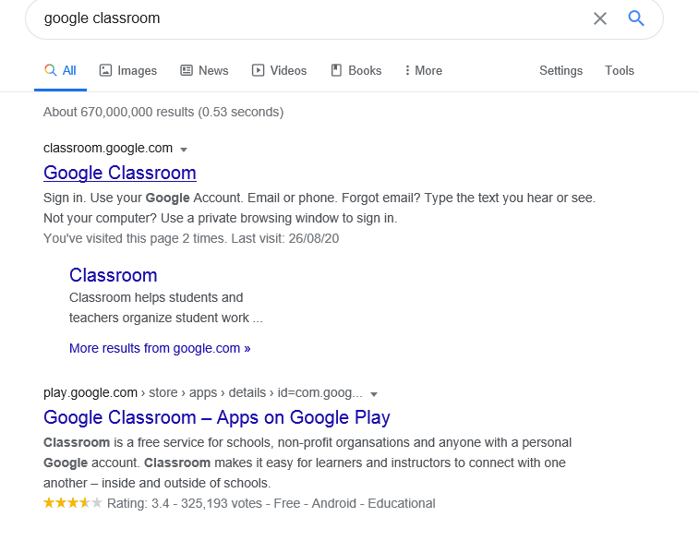
Step 3: add your details – username and password
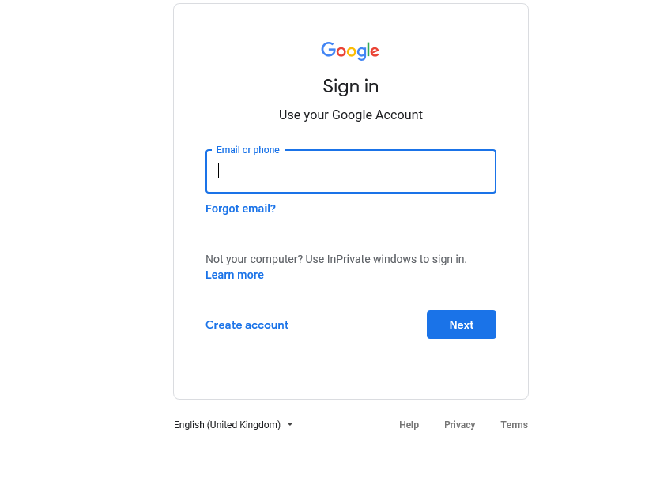

Step 4: you will see the classrooms you are part of. Click on your classroom.
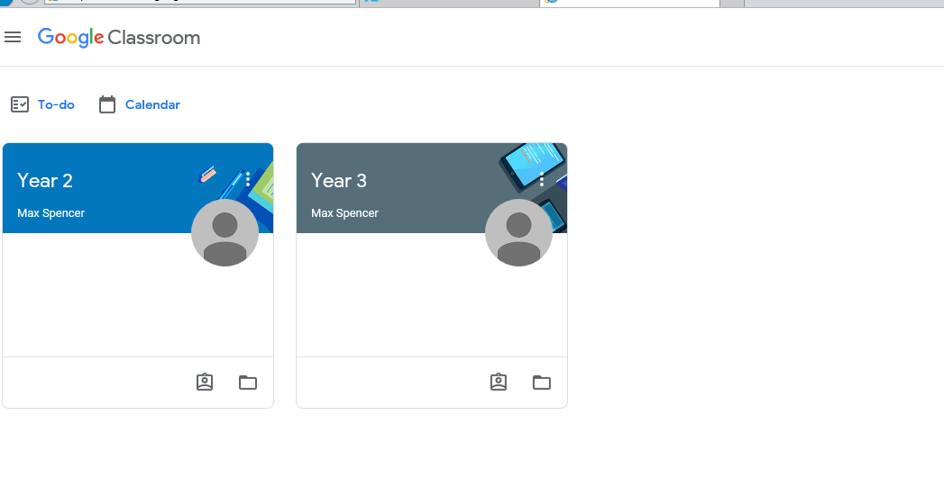
Step 5: check to see if you have any assignments
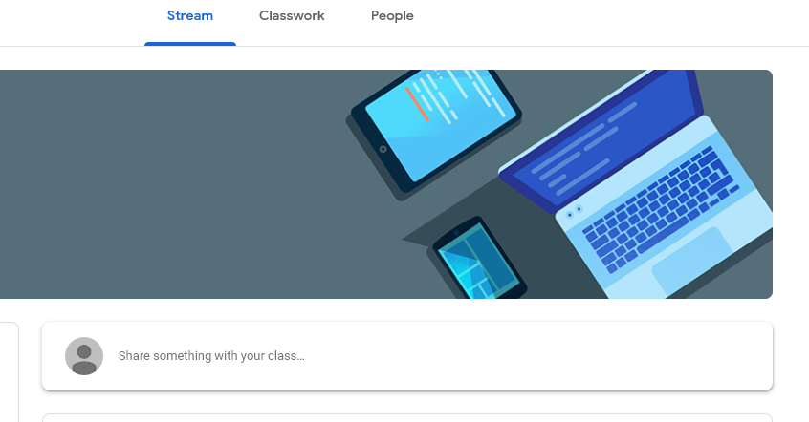

Step 6: click on the latest assignment to see your homework task
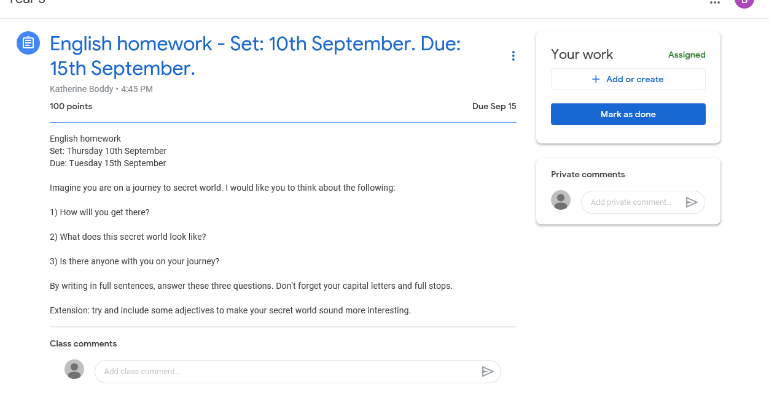
Step 7: completing your homework
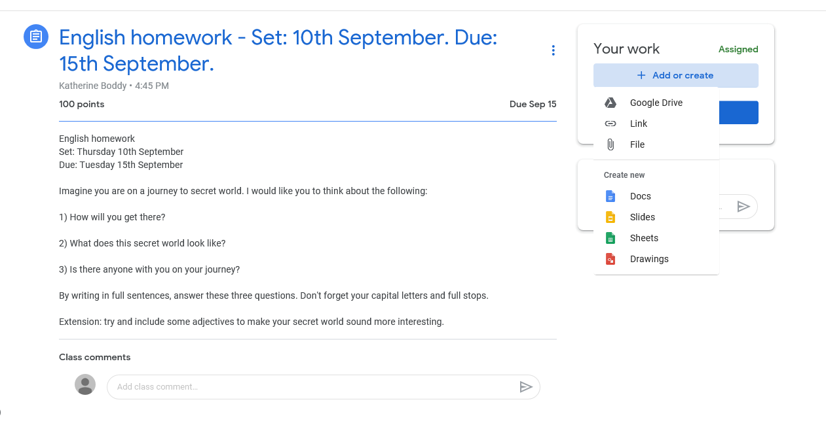
You will see that there are different ways you can complete your homework. You can either complete it on the computer or in your pink homework books. If you complete it in your pink homework book, your adult can take a photo and submit it by attaching the photo using the ‘file’ section.

Step 8: submitting your work
On the computer:
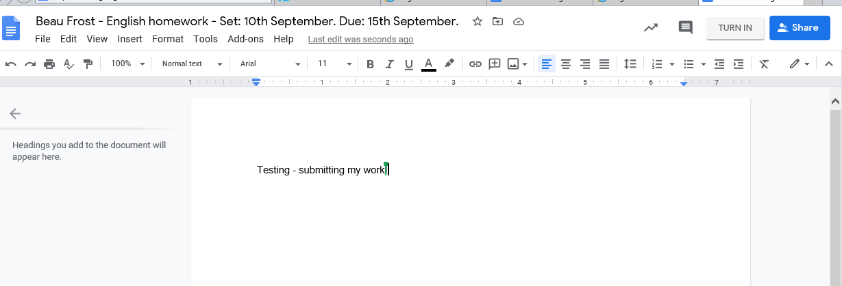
Complete your work then click ‘TURN IN.’
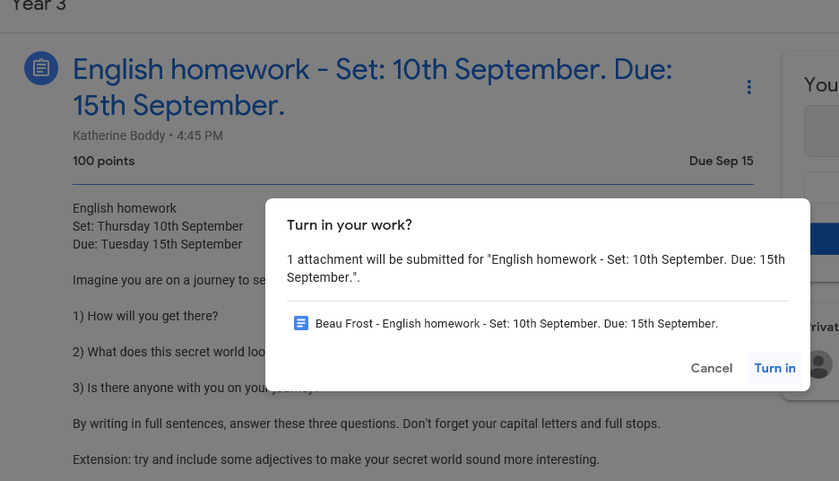

Using your pink homework books:
Follow the same steps up to Step 8 as shown above
Step 1: Log into Google classrooms on your phone
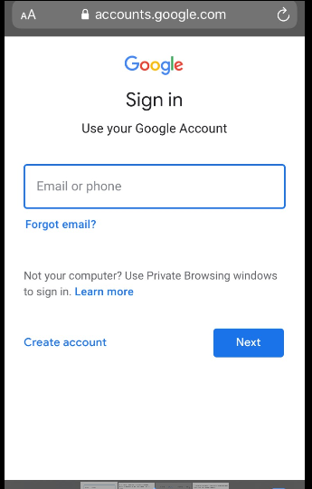
Step 2: Click on ‘file.’
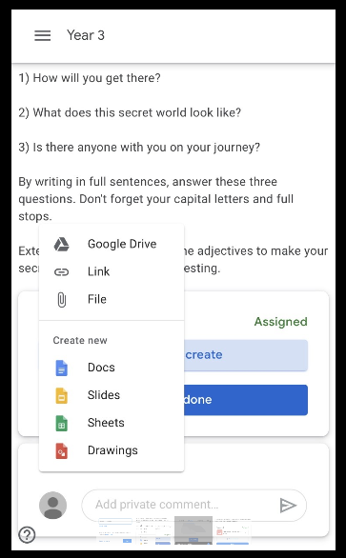

Step 3: Click ‘upload’ then ‘take photo or video’
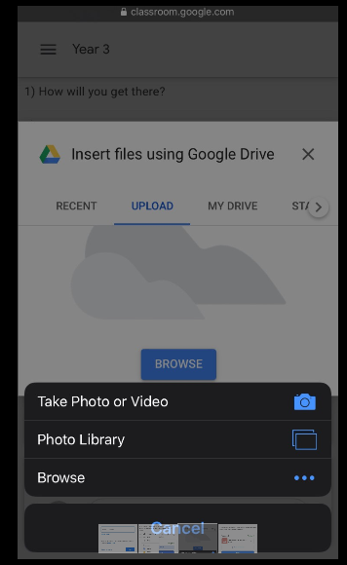
Step 4: submit your work by clicking ‘turn in’
