Parents’ Guide to Read Write Inc. Phonics. 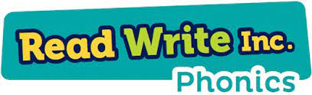
At Stonehill, we use the Read Write Inc. (RWI) programme to get children off to a flying start with their literacy. Read Write Inc. Phonics is a method of teaching reading and writing, which is centred around learning the sounds of the letters (phonics) and then blending them together to read words. The children also learn to break down words into individual sounds in order to write them.
When using RWI to read the children will:
• Learn to read effortlessly so that they can put all their energy into understanding what they read.
• Learn 44 sounds and the corresponding letter/letter groups using simple picture prompts.
• Learn to read words using Fred Talk.
• Learn to read words by blending the sounds together.
• Read lively stories featuring words they have learnt to sound out. • Show that they understand the stories by answering 'Find It' and 'Prove it' discussion questions.

Blending
Children learn to read words by blending the letter sounds that are in the Speed Sound sets. Help your child learn to read words by sound-blending e.g. c-a-t = cat. Help children to say the pure sounds, as quickly as they can and then to blend the sounds together to say the whole word.
Set 1 sounds.
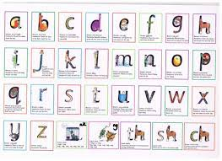

Set 2 sounds.
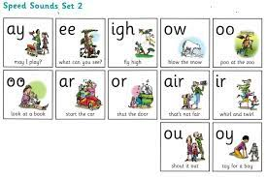
Set 3 sounds.
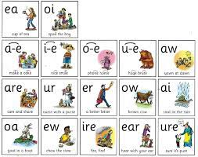
How will I know how to pronounce the phonic sounds?
http://www.ruthmiskin.com/en/parents/
To help the children with their writing, we use the following rhymes to help them to remember the correct letter formation. It would be most helpful, if you wish to support your child at home with their writing, if you also referred to these rhymes.
