September 2026
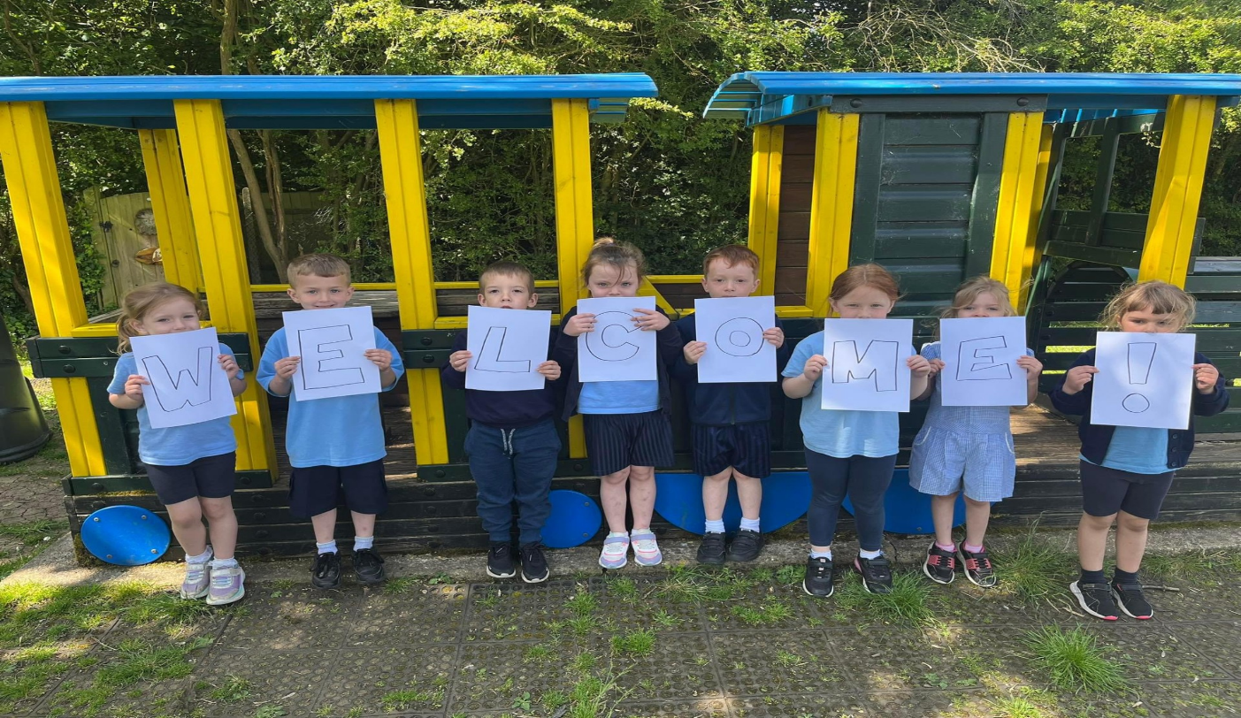

Dear Parents and Carers,

Welcome to all our families, those who know us well and those who are new to our school. We hope you are ready for lots of exciting learning in the Autumn term in our Early Years classes. Thank you for your support in making the children’s transition to Stonehill School happy and successful.

A few things your child will need are: a water bottle, a bag of spare clothes, welly boots and a book bag – all to be named please! Welly boots and spare clothes can be kept at school to ensure they are available as and when they are needed.

Children will have a daily snack time, which is either a fruit or vegetable snack and milk or water. Unfortunately, we cannot allow children to bring in their own snack due to severe allergies within both classes.

Our Topic: Let’s Explore

This project supports children with settling into the new rules and routines of school and encourages them to make new friends and feel confident in their class. It teaches children about being helpful, kind and thoughtful at home and at school. The project also teaches children about the environments that they share with others, including their homes, school and places within the local community.



During this topic the children will:

- Listen to others when one-to-one or in a small group, and start and continue a conversation with a friend.
- Begin to understand families are all different sizes, we are all unique and special and there are things we are good at and things we can learn more about.
- Learn that we need rules to keep us safe and happy, that it is important to listen to adults at school and follow what they say and that “I need to take turns when playing with my friends at school”.

Read Write Inc Phonics

Reception will begin to learn Read Write Inc Set 1 sounds alongside their red and green words, while Nursery will be learning nursery rhymes and playing lots of listening games. Reception parents will be able to attend a Read Write Inc information session later in the term to find out more about how we learn to read at Stonehill.

Online Resources

- Oxford Owl free reading resources

- Learn English Kids British Council: https://learnenglishkids.britishcouncil.org/category/topics/jobs

- Phonics Play Games:
https://www.phonicsplay.co.uk/

Library Books

Library books are changed weekly, on Thursdays for Nursery and Mondays for Reception. Please make sure your child’s book bag is in school each day. Your child will have the opportunity to choose a book that you can read to them at home.

Reading Books

Reading Books are changed weekly in Reception. Please ensure your child has their reading record and book wallet in school every day, as they will read regularly to an adult throughout the week. Your child will also have a reading record, which you can use to record when your child reads at home.

PE

PE is on Wednesdays for both Nursery and Reception. Reception children should come into school on Wednesdays wearing their PE kit in the school colours of navy and pale blue. Please make sure you have full PE kit by October half term at the latest.

Important Information

We will keep a learning journey to record your child’s work and skills learnt throughout the year. You will have the opportunity to share these regularly with your child later in the term. In Early Years it is key for the adults to be modelling through play and teaching the importance of rules and routines, therefore we will not be recording every new skill. The first half term is a crucial time for us to get to know each individual child and their current skills. Although we will be observing the children daily, these observations will not be shared.

We will share weekly updates and learning for Reception and Nursery via MarvellousMe this half term and our weekly noticeboard that will be sent to you. We also share exciting activities and learning information on our Facebook Page: Stonehill School Early Years.

Please don’t hesitate to contact us to discuss your child’s learning or for any other reason.

annadenton@stonehill.herts.sch.uk
laurawebster@stonehill.herts.sch.uk

Yours sincerely,
Early Years Team

 | Anna Denton  Liza Anderson |  |  | Laura Webster  Maria Sawyer
 | Mrs Anna Denton  Mrs Liza Anderson  Nursery |  |  | Miss Laura Webster  Miss Maria Sawyer  Reception

